**Circuit Diagram:**

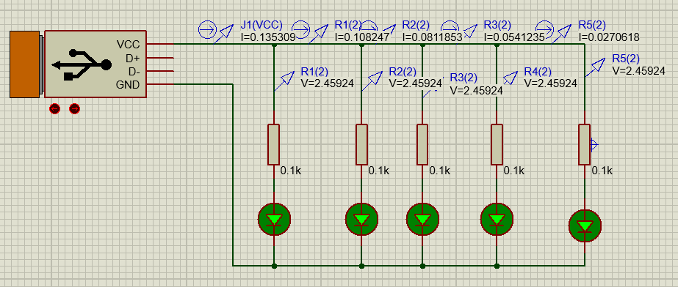

**Calculation:**

IT=V/RT

As we know that the each individual resistance is 100ohm and all are in parallel so

1/Rt= 1/R1 +1/R2 +1/R3 +1/R4+1/R5

As all resistances are of 100ohm so

1/Rt=5/100

Rt=20ohms

Putting the value of Rt in above equation so it becomes

IT=5/20

IT=0.25A

**Comments:**

As all the resistances are in parallel and we know that the voltage in parallel remains same and current is different and this is cleared in the above picture. As all resistances are in parallel so kCL applies in this case and KCL says that current in all branches is equal to the total current and same thing is appeared in the above circuit.